GPT NLP Lab Assistant Group 3
Muhammed Faseeh, Michael Fritzer
David Haybarger, Kevin Lee

Concept of Operations

Concept of Operations
for
UPDATE TO REFLECT REALITYGPT NLP Lab Assistant Group 3

Team <35>

Approved by:

Michael Fritzer 10/03/2025
_____________________________
Project Leader Date

Byung-Jun Yoon 09/12/2025
_____________________________
Professor Date

Fahrettin Ay 09/16/2025
_____________________________
T/A Date

Change Record
Rev. | Date | Originator | Approvals | Description
1 | 09/12/2025 | Michael Fritzer,  Muhammed Faseeh,  David Haybarger,  Kevin Lee | Michael Fritzer,Fahrettin Ay,Byung-Jun Yoon | Created initial ConOps.
2 | 10/03/2025 | Michael Fritzer,  Muhammed Faseeh,  David Haybarger,  Kevin Lee | Michael Fritzer | Updated ConOps per feedback given by Fahrettin.
3 | 12/3/2025 | Michael Fritzer,  Muhammed Faseeh,  David Haybarger,  Kevin Lee |  | Updated ConOps to new project name and acronym.  Updated Referenced Documents and Standards.

Table of Contents
1. Executive Summary 5
2. Introduction 5
2.1. Background 5
2.2. Overview 6
2.3. Referenced Documents and Standards 6
3. Operating Concept 7
3.1. Scope 7
3.2. Operational Description and Constraints 7
3.3. System Description 8
3.4. Modes of Operations 9
3.5. Users 9
3.6. Support 10
4. Scenario(s) 11
4.1. Scenario Name #1 11
4.2. Scenario Name #2 11
5. Analysis 13
5.1. Summary of Proposed Improvements 13
5.2. Disadvantages and Limitations 13
5.3. Alternatives 14
5.4. Impact 14
5.5. List of Figures 15

Executive Summary
The Autonomous University Robot Assistant (AURA) is an AI-powered laboratory assistant designed to improve learning and research efficiency in university teaching and research labs. Built on the Jetson Orin Nano with integrated camera, microphone, and touchscreen, AURA combines natural language processing, computer vision, and voice interaction to answer lab questions, reference documentation, and support troubleshooting.

The system’s main benefits include reducing dependency on teaching assistants for routine questions, providing instant access to reliable information, and reinforcing lab safety. AURA uses retrieval-augmented generation (RAG) over curated manuals, SOPs, and course material to ensure responses are accurate and source based.

By logging interactions for later review and supporting multimodal input (voice, text, and image), Temlog demonstrates how AI can augment human instruction and streamline lab operations. Deliverables include a fully assembled assistant, integrated AI backend, and a user friendly interface for interaction and data review.

Introduction
The AURA project aims to design and implement an AI-powered laboratory assistant that combines natural language processing, computer vision, and robotics to support teaching and research environments. The system is intended to answer student questions, assist with troubleshooting, and provide real time access to lab procedures and safety information through a conversational interface.

Background
Traditional teaching and research labs depend on human TAs to answer questions and troubleshoot problems. This creates bottlenecks when labs are crowded, and students often struggle to find timely support. Digital resources such as PDFs and manuals require manual searching, which interrupts workflow and increases the risk of mistakes.
The AURA project addresses these challenges by offering a conversational, multimodal AI system capable of answering questions, recognizing lab components, and providing guidance in real time.

Overview
AURA is a GPT based conversational assistant running on the Jetson Orin Nano. It supports:
- Voice based interaction through speech recognition and text-to-speech.
- Basic computer vision to identify components and cross check schematics/diagrams.
- A touchscreen interface for file uploads, settings, and logs.
- Session logging to a remote database for analysis and instructor review.
- Interactive autonomous movement

Referenced Documents and Standards
Jetson Orin Nano Super Developer Kit

Proposed Screen/Display

Project Flowchart

Github Repository

OpenAI API Documentation

Power Bank Reference

LightRag Reference Paper

Segment Anything Model Reference

Local LLM Github Repository

Operating Concept

Scope
This project involves the design and development of the Technical Logger (Temlog), a physical, AI-powered lab assistant built on the Jetson Orin Nano 2020 board. It is designed to support lab environments by answering questions through natural language, recognizing users through voice and facial input, and interpreting visual data (e.g., photos of circuits or schematics). Temlog will provide intelligent, context-aware support in research and teaching labs, augmenting traditional TA roles.
Scope includes:
- Voice-based Q&A using a Locally ran LLM
- Vision-based recognition (e.g., identifying resistor values, object recognition)
- Local touchscreen interface with USB file handling
- Logging of interactions for analytics and review
- Deployment of speech-to-text, text-to-speech, and camera-based interactions on the Jetson board
Limitations:
- No autonomous navigation or robotic manipulation
- Online connectivity required for full GPT functionality
- Limited physical interaction; acts as a smart assistant, not a robot manipulator

Operational Description and Constraints
Temlog operates as an intelligent lab assistant placed on a lab bench or table. Upon hearing a wake word ("Hey Temlog"), it initiates a GPT-based conversation session that can include visual inputs (via camera), voice queries, or document uploads. Once the session concludes (based on timeout, thank-you, powering down, or token limit), the conversation is logged and uploaded to a central database.
Constraints include:
- Requires stable internet for API usage and logging
- Ambient noise may affect wake word or STT accuracy
- File parsing limited to supported formats (PDF, PNG, JPG)
- Power draw must be managed efficiently due to Jetson Orin's processing demands

System Description
Temlog is built around the Jetson Orin Nano 2020, which acts as the central compute unit, replacing the Raspberry Pi. It integrates multiple subsystems:
- AI Assistant Backend
  - GPT-4 via OpenAI API
  - Prompt-engineered for lab-specific Q&A
  - Multimodal input: text, voice, image
  - RAG-powered knowledge base for sourcing answers from lab documents
- Hardware & UI (Jetson Orin)
  - Touchscreen display for user input, file browsing, settings (voice, face, volume)
  - USB A support for file sharing/uploading
  - Onboard storage for caching and external microSD/SSD if needed
  - Real-time visual feedback (resting face, notifications)
- Vision & Audio Subsystems
  - Pi Camera Module connected to Jetson Orin for object recognition and face detection
  - Microphone array for speech input and wake-word recognition
  - Text-to-Speech engine for spoken responses
- Robotic Integration (ESP-32)
  - Basic expressive motions (eye movement, gestures)
  - Optional motor actuation for animations
  - GPIO support for peripheral inputs (LEDs, sensors, buttons)

Modes of Operations

Mode | Functionality
Idle Mode | Default resting state. Displays passive expression on screen, listens for wake word (“Hey Temlog”) or screen interaction. Minimal resource use.
Interaction Mode | Active GPT-based conversation initiated by voice or file input. Supports voice queries, image analysis, and returns text/speech/file responses. Ends after 15s idle, user “thank you,” or token limit (avoids abuse).
File Mode | Allows users to input files via USB (PDFs, schematics, images). Touchscreen UI used to view, delete, and manage uploaded content.
Settings Mode | Accessible via touchscreen or command. Lets users adjust voice options, select bot “face” or idle animations, change system volume, reset session logs, or activate kill switch. Password-protected for safety-critical functions.
Admin Mode | Allows instructors or TAs to manage local document repositories, upload new SOPs or safety sheets, clear cache, or access usage logs.
Developer Mode | For debugging and configuration by developers. Exposes hardware diagnostics, service logs, API keys, model parameters, and system health metrics. Accessible via SSH, serial port, or secure UI command. Used during testing, integration, and upgrades.
Maintenance Mode | Used for firmware or software updates, cleaning logs, testing sensors, or hardware calibration. Typically entered during lab downtime. May disable core functionality temporarily.
Offline Mode | Indicates lack of internet/API access. Disables GPT services but allows file navigation, basic UI interaction, and local troubleshooting. Can still summon documents via local LLM & RAG system.
These additional modes make the system modular, role-based, and resilient, while supporting both end-users and devs during setup or expansion.

Users

User Group | Description
Students (Primary Users) | No training required. Can interact via voice or touchscreen. Upload files, ask questions, receive visual/audio feedback.
Instructors / TAs | Can update the knowledge base, add lab-specific documents, access logs, adjust settings. Moderate training recommended.
Developers /Maintainers | Hardware/software maintainers. Require familiarity with Jetson Linux, ESP-32, and system architecture.
Users benefit from instant access to technical support, real-time visual diagnostics, and searchable conversation logs.

Support
Support will be delivered through:
- On-Device UI: Help menus, error messages, session status, email.

Scenario(s)

Lab Safety and Equipment Setup
An undergraduate student in an Electronics I lab is preparing to operate a power supply for the first time. The TA is occupied, so the student asks Temlog:
- Student: “Hey Temlog, how do I safely connect the bench power supply to my circuit?”
- Temlog: “First, confirm the voltage requirements of your circuit. For today’s op-amp lab, keep it under ±15V. Always turn the supply off before connecting wires.”
- The student holds the front panel of the power supply up to the camera. Temlog detects the channel labels and highlights the correct positive, negative, and ground terminals on the screen.
- Temlog: “Connect red to +15V, black to ground. Make sure your circuit’s ground is in common with the supply ground.”
- The student completes the setup, thanks Temlog, and begins the experiment. The interaction log is saved with a timestamp for the instructor’s review.

4.2. Assisting with Research Lab Documentation and Data Review
Overview:
A graduate researcher in an electrical engineering research lab is preparing a weekly update for their advisor. They need to summarize lab notes, retrieve previous troubleshooting steps, and verify part of a circuit configuration using documentation.
Steps:
- The researcher walks up to Temlog and says:
“Hey Temlog, can you pull up last Tuesday’s circuit setup for the inverter tests?”
- Temlog checks the timestamped database logs and responds via speech and screen:
“Found a file from Tuesday labeled ‘Inverter_Setup_Scan_09-09.pdf’. Displaying it now.”
The document is shown on the screen.
- The researcher replies:
“What values were used for the gate resistor and the load capacitance?”
- Temlog reads the PDF and says:
“Gate resistor: 220Ω. Load capacitance: 100nF. These were noted in the test config block on page 2.”
- The researcher follows up:
“Summarize the three main issues reported that day.”
- Temlog responds:
“1. Gate ringing above 6V due to probe grounding.
2. MOSFET temperature exceeded the safe limit after 15 minutes.
3. Signal distortion in output waveform under high load.”
- The researcher says:
“Thanks, can you save this session as ‘Advisor Summary’?”
- Temlog saves the transcript to the cloud and confirms:
“Session logged and titled ‘Advisor Summary.’ You can access it anytime from your account.”

4.3. Preparing for Lab Practical Exam
Overview:
An instructor assigns students a lab practical exam where they must independently configure an op-amp circuit. A student decides to practice using Temlog before the exam.
Steps:
The student approaches Temlog and says:
“Hey Temlog, can you quiz me on setting up an inverting amplifier circuit?”
Temlog replies:
“Sure. Step 1: Where should you connect the input signal? Step 2: Which pin must be connected to ground? Step 3: How do you calculate the gain from resistor values?”
The student answers each step. Temlog provides corrective feedback:
“Correct the input signal goes to the inverting input through the resistor. The non-inverting input should be grounded. Remember, the gain is -Rf/Rin.”
The student then uploads a photo of their breadboard setup. Temlog analyzes it and responds:
“Good placement. However, the feedback resistor should connect directly between the op-amp’s output and inverting input. Adjust that for stability.”
After making the correction, the student confirms understanding. Temlog saves the interaction under “Op-Amp Exam Practice” for later review.

4.4. Checking Component Values Before Use
Overview:
A first-year student in an Intro to Circuits lab needs to confirm the value of a resistor before inserting it into their breadboard. They are unsure how to read the color bands.
Steps:
The student says:
“Hey Temlog, what value is this resistor?”
The student holds the resistor up to Temlog’s camera. Temlog uses its vision system and responds:
“This resistor has bands brown, black, orange, and gold — that corresponds to 10kΩ with ±5% tolerance.”
The student replies:
“Thanks, that’s what I needed.”
The session is logged under “Component Identification.”

Analysis

Summary of Proposed Improvements
The Temlog system introduces significant improvements to the traditional lab environment:
- Reduces TA workload by offloading routine student queries
- Increases student access to help, especially in high-volume labs
- Adds multimodal support — students can show hardware, upload files, and speak naturally
- Logs conversations for transparency, grading, and refinement
- Promotes self-guided learning by giving students instant, repeatable, non-judgmental help
- Acts as a live TA simulator for practice outside lab hours

Disadvantages and Limitations
Despite its benefits, Temlog has several known limitations:
- Internet-dependence: GPT API and cloud features require a stable connection
- No mobility: Cannot physically interact with circuits or move to student stations
- Vision limitations: Circuit recognition relies on lighting and clarity of camera feed
- AI misunderstandings: Misinterpretation of vague questions or novel lab setups
- Training requirements: Developers and instructors must maintain the knowledge base and keep prompts accurate

Alternatives

Alternative | Pros | Cons
More TAs | Human nuance, mobility, real-time adjustment | Budget constraints, human error, TA availability
Traditional Help Desk (Docs & PDFs) | No hardware required, static and easy to scale | Not interactive, requires student effort to search
Static FAQ chatbot (Web-based) | Lower compute requirement, no hardware | Lacks visual/audio interaction, can’t “see” circuits
Trade-off Summary:
Temlog offers the best balance between automation and student engagement, with voice, visual, and text integration — though at the cost of upfront hardware complexity and API reliance.

Impact
Environmental Impact:
- Neutral to low: Power draw is limited; uses Jetson Orin Nano and ESP-32, both energy-efficient. Plastic enclosures can be made from recycled materials.
- Positive: Reduces paper-based manuals, printed lab guides, and in-person load.
Societal Impact:
- Positive: Enhances accessibility for students with disabilities or ESL learners.
- Supports scalability in large or under-staffed engineering programs.
Ethical Concerns:
- Bias: Responses generated by GPT must be monitored to prevent inappropriate or incorrect replies.
- Data Logging: Conversation logs must be anonymized and securely stored to protect student privacy.
- Over-reliance: Some students may overly depend on Temlog instead of learning foundational troubleshooting skills.

List of Figures

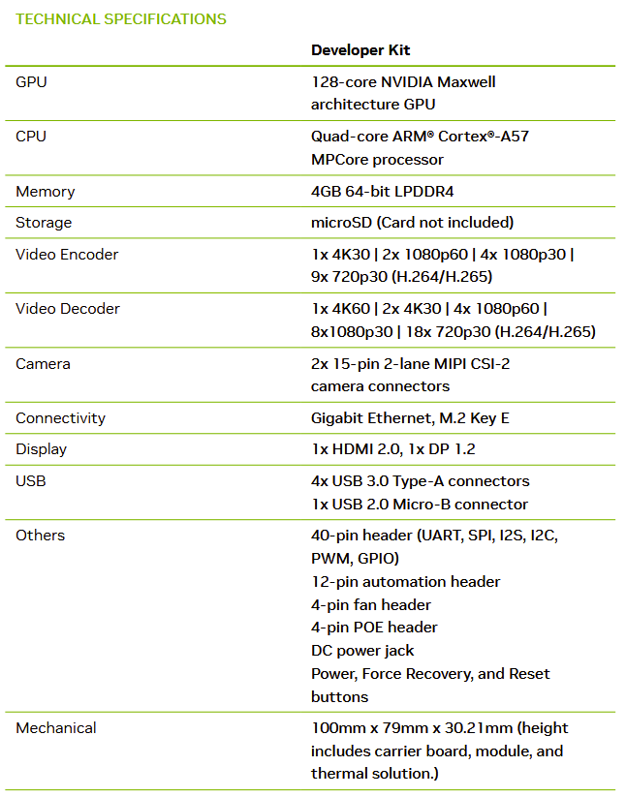

Figure 1: Specs sheet for Jetson Nano model P3450
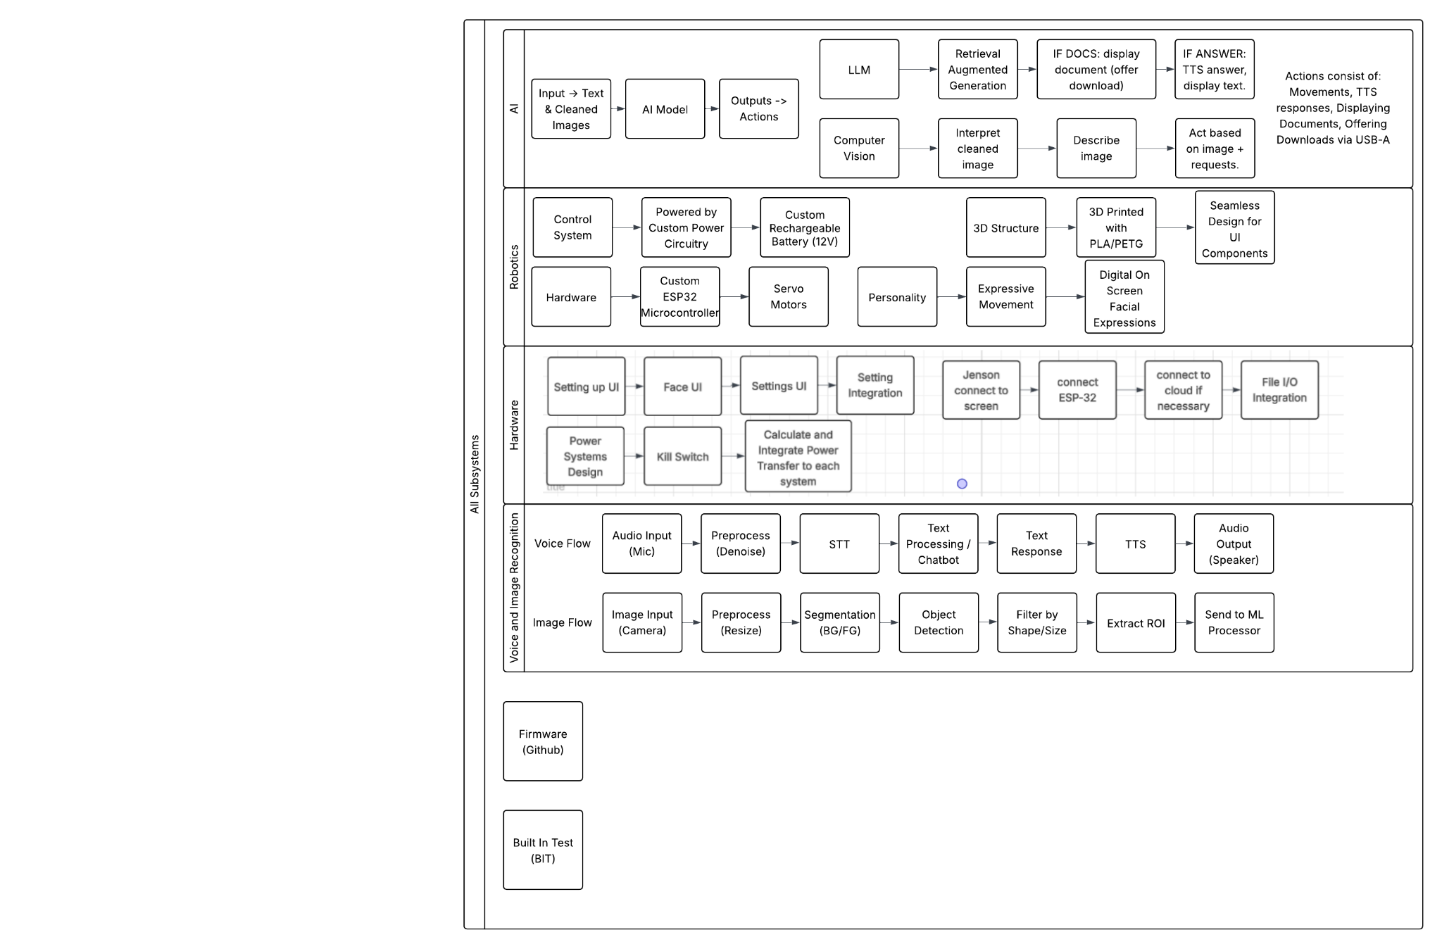
Figure 2: Subsystem Flowchart

